Year 3 Spellings – Autumn 1

Week 1 (to be tested 29/9/26)  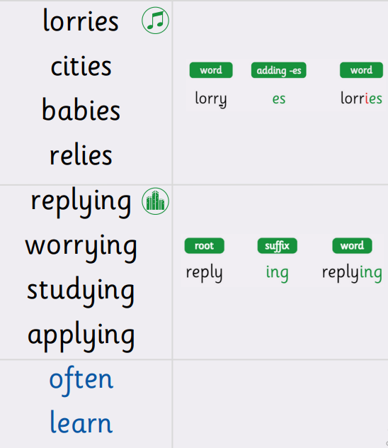 | Week 2 (to be tested 5/10/26)  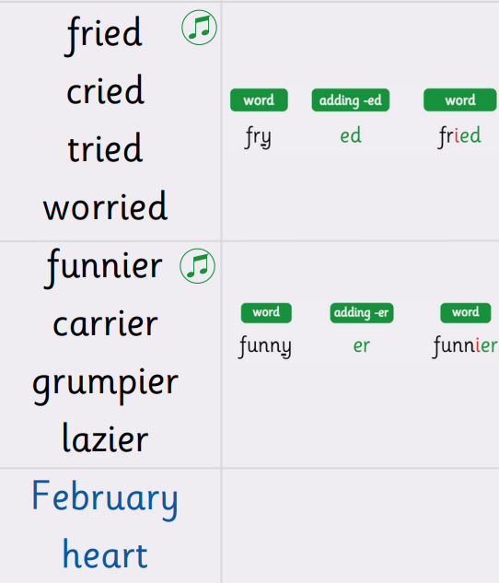
Week 3 (to be tested 12/10/26)  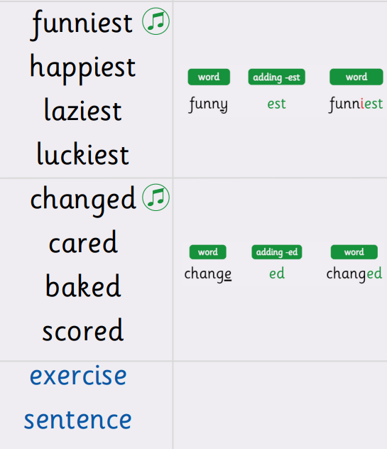 | Week 4 (to be tested 19/10/26)  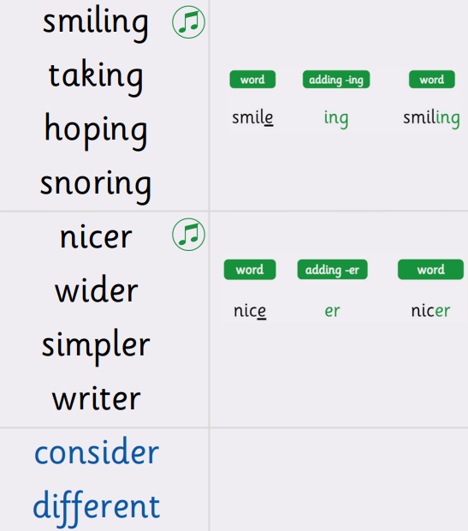
Week 5 (to be tested 2/11/26)  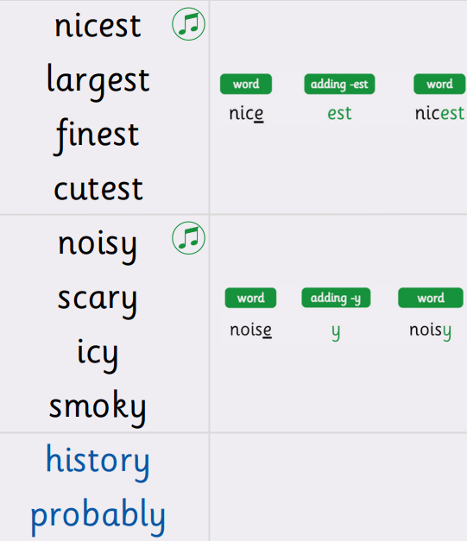 | We have an exciting new spelling scheme that we are launching this week, called ‘Ready, Steady, Spell!’  Each week we shall be looking at a new pattern and learning spelling strategies to help secure these spellings.  I shall send home the half term’s learning, so that you have an overview all on one document.  The children will also have them in their planners.  Please work at your child’s level. Some children have a specific barrier with spelling, so in that case there is no expectation that they should learn all the words- just the ones highlighted on the list in their planners.  Please ask if you have any questions at all.  Best wishes, Miss Cross

