**Mathematical Understanding**

**As mathematicians, we will:**

* Count in multiples of 4, 8, 50 and 100
* Recognise the place value of digits in 3-dgit numbers
* Compare and order numbers to 1000
* Identify, represent and estimate numbers using representations
* Read and write numbers up to 1000 in numerals and words
* Add and subtract numbers with up to 3 digits using mental and written methods
* Estimate the answers to a calculations and use inverse operations to check answers
* Solve problems, including missing number problems, using number facts, place value, and more complex addition and subtraction
* Recall and use multiplication and division facts for 2x, 3x, 4x, 5x, 8 and, 10x tables
* Write and calculate statements for multiplication and division
* Solve problems, including missing number problems

**Scientific and Technological Understanding**

**As scientists, we will:**

* Name the nutrients found in food
* State that to be healthy we need to eat the right types of food to give us the correct amount of these nutrients
* Name some bones that make up the skeleton, giving examples that support, help them move or provide protection
* Describe how muscles and joints help them to move
* Know that rock is a naturally occurring material
* Name some types of rock and understand the features
* Understand how a fossil is formed
* Explain that soils are made from rocks and also contain living/dead matter**As computer scientists and programmers we will:**
* Identify inputs, outputs, processes and how devices can be connected to networks
* Capture and edit digital still images to produce a stop-frame animation that tells a story

**Understanding English, Communication and Language**

**As linguists we will:**

* Plan, draft, redraft and edit our writing
* Look at specific spelling patterns and application of those in writing
* Use a paperback dictionary confidently
* Compose and rehearse sentences orally
* Use conjunctions to extend sentences
* Begin sentences with fronted adverbials followed by a comma
* Develop the accurate use of paragraphs
* Use direct speech and punctuate accordingly
* Use and understand grammatical terminology
* Read aloud to the whole class using appropriate intonation
* Read a range of text types and analyse the features
* In French, we will learn vocabulary related to Numbers 1-10, greetings and saying how you are, classroom instructions, ask for and give name, ask for and state age, colours

**Human, Social and Environmental Understanding**

**In RE, we will:**

* Understand the trinity
* Explore and compare differences and similarities between the Christians, Jewish and Muslim understanding of God
* Recognise the impact of the fall in Christian thinking

**As geographers, we will:**

* Understand why we have capital cities and explain why most significant cities are situated next to a river
* Recognise the difference between a major city and a town or village
* Recall the names and purpose of many of London’s famous buildings
* Recall the names of other European capitals

**As historians, we will:**

* Understand prehistoric Britain’s chronology of Stone age – Bronze age – Iron age
* Understand that historians have no written records from this time but some physical primary artefacts remain (cave art and tools)
* Learn about the significant move from hunter gatherers to established farming (include timeline)
* Understand the differences and similarities between life in the Stone, Bronze and Iron ages.

**Understanding the Arts and Design**

**As artists, we will:**

* Understand what pop art is
* Learn about the life and work of Andy Warhol
* Know the proportions of the face
* Create a pop art style portrait

**As design technologists, we will:**

* Research, design, make and evaluate packaging for a fragile food

**As performers, we will:**

* Through a range of performance, composition and listening activities, explore how music can be used to develop different characters in sound
* Use Stone Age as a stimulus to create our own lyrics to a known melody to create a new version of a song
* Use rhythmic notation to write short rhythmic phrases

**We will use the outdoor environment to enhance learning opportunities across the curriculum.**

**‘OUR YEAR 3 JOURNEY’**

**Autumn Term 2024**

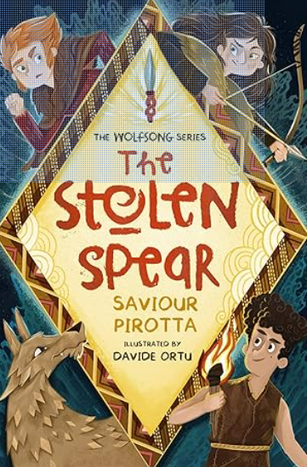

**Understanding Physical Health and Well-Being**

**As responsible citizens, we will:**

* Participate fully in group discussions and activities
* Recognise what makes a good friend, understand the importance of personal space and resilience
* Understand that everyone is different, but equal; Recognise how to value and respect others In our school community

**As athletes, we will learn to:**

* Develop our swimming strokes and stamina
* Understand the impact of sport on our health and well being
* Invasion games- Football and Tag Rugby